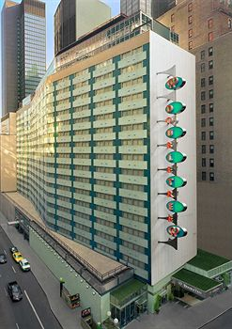Metropolitain hotel in New York close to Central Park

569 Lexington Avenue, New York, New York, 10022, USA

Near the hotel there is:

1. the empire state building 1Mile

2. Metropolitain Museum of Art 2.2 Miles

3. Metropolitain Opera 2.3 Miles

